

JD COLLEGE OF ENGINEERING AND MANAGEMENT, NAGPUR

CLOUD COMPUTING ACTIVITY (TECHNICAL TOOL) REPORT

Topic:
Git & GitHub

Made By:
Abhishek Gupta (BT230004CS)

Class & Branch:
6th SEM CSE - A
Introduction:
Git and GitHub are widely used tools for version control and collaborative software development. Git is a distributed version control system that enables developers to track changes in source code, manage different versions of a project, and collaborate efficiently without overwriting each other’s work. It allows users to maintain a complete history of modifications, revert to previous versions when required, and manage multiple branches of development simultaneously.
GitHub is a cloud-based platform that hosts Git repositories and provides additional features such as remote storage, collaboration tools, access control, issue tracking, and integration with deployment pipelines. It allows developers to store their projects online, collaborate with team members from different locations, and integrate with various cloud services for automated deployment and continuous integration.
In the context of Cloud Computing, Git and GitHub play a crucial role in managing application source code, enabling remote access, supporting DevOps practices, and facilitating cloud-based application deployment. These tools form an essential part of modern software development workflows and are widely adopted in industry for efficient project management and cloud-based development environments.
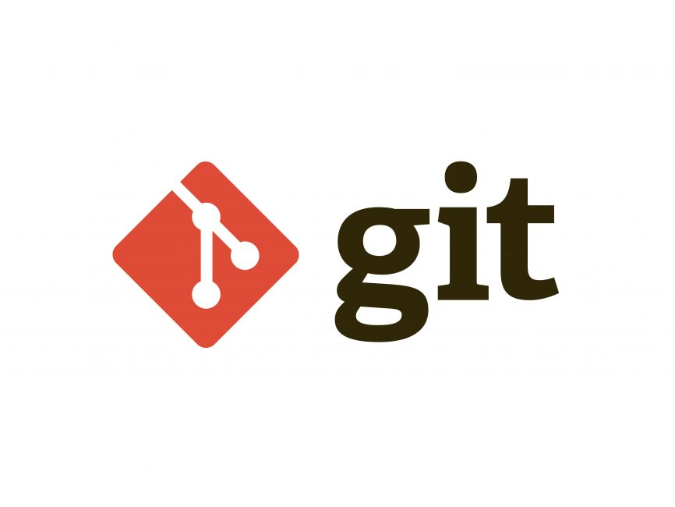

Where to use Git and GitHub:
Git and GitHub are widely used in various domains of software development, especially in environments that require version control, team collaboration, and cloud-based project management. These tools are particularly important in modern development workflows where applications are developed, tested, and deployed in cloud environments.
One of the primary areas where Git and GitHub are used is in cloud-based application development. Developers use Git to manage source code versions locally, while GitHub provides a remote repository hosted on the cloud. This enables multiple developers to work on the same project from different geographical locations without conflicts.
GitHub is also extensively used in DevOps practices. It integrates with cloud platforms such as Amazon Web Services (AWS), Microsoft Azure, and Google Cloud Platform (GCP) to support Continuous Integration and Continuous Deployment (CI/CD) pipelines. This allows automatic building, testing, and deployment of applications directly from a GitHub repository to a cloud server.
In addition, Git and GitHub are used in:
- Web development projects for managing frontend and backend code.
- Open-source software development, where contributors collaborate globally.
- Enterprise software systems, where version tracking and controlled access are critical.
- Academic and research projects, for maintaining documentation and source code history.
- Microservices architecture, where different services are maintained in separate repositories.
Within the field of Cloud Computing, GitHub serves as a centralized cloud-based repository that enables secure storage, remote access, collaboration, and integration with cloud hosting platforms. It ensures efficient project management, code reliability, and smooth deployment processes.

How to use Git and GitHub:
Git and GitHub are used together to manage source code, maintain version history, and enable cloud-based collaboration and deployment. The typical workflow involves initializing a local repository using Git, connecting it to a remote repository on GitHub, and then managing updates through commits and synchronization.
The general steps involved in using Git and GitHub are as follows:
1. Installation and Configuration: First, Git must be installed on the local system. After installation, the user configures Git using their name and email address. This ensures that all commits are properly identified. Example configuration commands:
git config --global user.name "Your Name"
git config --global user.email "your_email@example.com"
2. Initializing a Local Repository: A project folder is created on the local machine. Inside this folder, Git is initialized using: git init, this creates a local repository that begins tracking project files.
3. Adding and Committing Files: After creating or modifying files, changes are added to the staging area using: git add .
The changes are then saved permanently in the repository using: git commit -m "Initial commit"
This process creates a version history of the project.
4. Creating a Repository on GitHub: A new repository is created on the GitHub platform. GitHub acts as a cloud-based remote repository that stores the project online. The local repository is then connected to GitHub using:
git remote add origin https://github.com/username/repository-name.git
5. Pushing Code to GitHub: The local project is uploaded to the GitHub repository using:
git push -u origin main, this uploads the project files to the cloud, making them accessible remotely.
6. Updating and Synchronizing Changes: Whenever modifications are made, the same add–commit–push cycle is repeated. This ensures that the GitHub repository remains updated with the latest version of the project.
7. Cloud-Based Deployment Integration: GitHub can be integrated with cloud platforms such as AWS, Azure, or GitHub Pages to automatically deploy applications. Once the repository is connected to a cloud hosting service, any updates pushed to GitHub can trigger automatic deployment, supporting Continuous Integration and Continuous Deployment (CI/CD).
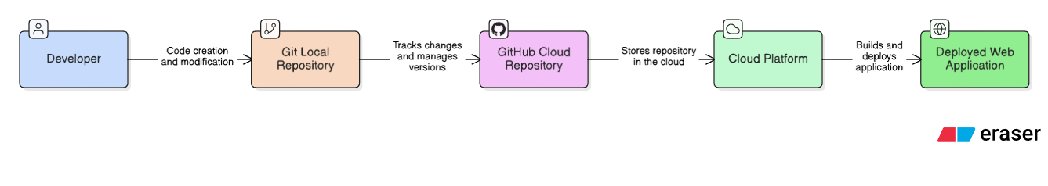

Applications
Git and GitHub are widely used in modern software development and cloud computing environments. Their applications extend beyond basic version control and support collaborative development, cloud deployment, and automated workflows. The major real-world applications of Git and GitHub are as follows:
1. Cloud-Based Application Development and Deployment: Git is used to manage source code locally, while GitHub stores the repository in a cloud environment. These repositories can be directly integrated with cloud platforms such as Amazon Web Services (AWS), Microsoft Azure, and Google Cloud Platform (GCP) for hosting and deploying web applications.
2. Continuous Integration and Continuous Deployment (CI/CD): GitHub integrates with automation tools to enable Continuous Integration and Continuous Deployment (CI/CD). Whenever code is pushed to the repository, automated testing and deployment processes can be triggered, ensuring faster and more reliable software delivery.
3. Open-Source Software Collaboration: GitHub provides a platform for developers worldwide to collaborate on open-source projects. Multiple contributors can work on the same repository using branching and merging strategies, supporting distributed development.
4. Enterprise Project Management: Organizations use Git and GitHub to manage large-scale software systems. Features such as version history tracking, branch management, access control, and issue tracking help maintain structured development processes.
5. Microservices Architecture Management: In cloud computing, applications are often divided into independent microservices. Each microservice can be maintained in a separate GitHub repository, enabling modular development and scalable deployment.

Conclusion
In conclusion, Git and GitHub are essential tools in modern software development and cloud computing. Git enables efficient version control, while GitHub provides a cloud-based platform for collaboration, repository management, and deployment integration.
Through applications such as cloud-based deployment, Continuous Integration and Continuous Deployment (CI/CD), open-source collaboration, and microservices management, these tools support scalable and structured development workflows. Overall, Git and GitHub form a fundamental part of today’s cloud-driven software ecosystem.

